

CAPSTONE PROJECT REPORT
Report 4 – Software Design Specification

– Hanoi, Jan 2025 –

Table of Contents
I. Record of Changes 3
II. Software Design Document 4
1. High Level Design 4
1.1 Software Architecture 4
1.2 Package Diagram 6
1.3 Database Design 8
2. Detailed Design 38
2.1 Authentication 38
2.1.1 Class Diagram Authentication 38
2.2 Course 40
2.3 Student 41
2.4 Quiz 42
2.5 AI 43
2.6 Granding 44

I. Record of Changes
Date | A*  M, D | In charge | Change Description
27/2/2026 | A | DatMN | Add Package Diagram, Database Design Diagram, Database Description
3/3/2026 | A | DatMN | Add Class Diagram, Sequence Diagram
3/3/2026 | A | LinhVTK | Add Software Architecture
10/3/2026 | M | DatMN | Modify Software Architecture
28/3/2026 | M | DatMN | Modify Package Diagram
28/3/2026 | M | DatMN | Modify Software Architecture
29/3/2026 | M | DatMN | Modify Database Design Diagram
16/4/2026 | M | DatMN | Modify Class Diagram, Sequence Diagram
17/4/2026 | M | DatMN | Modify Database Design Diagram
*A - Added M - Modified D - Deleted

II. Software Design Document

1. High Level Design

1.1 Software Architecture
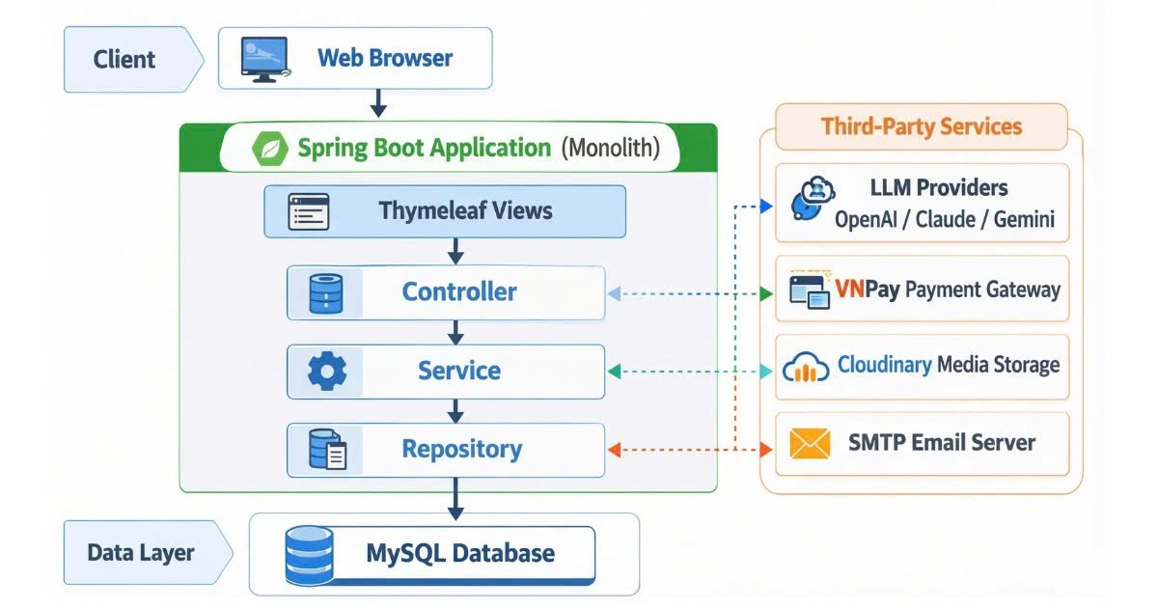

1.1.1 Component Description

A. Client Layer
Web Browser: The primary client interface. It sends HTTP requests to the server and rendersLayout: Handles the structural skeleton ensuring consistency across pages (Header, Sidebar, Footer).

B. Spring Boot Application (Monolith)
The core application serves as both the presentation and business logic layer. It is implemented as a structured monolithic Spring Boot system responsible for rendering UI, processing business rules, and communicating with external services and the database.

- Thymeleaf Views: The presentation layer. It is responsible for rendering server-side HTML views and passing user interactions down to the Controller.
- Controller: The routing and request-handling layer. It receives requests from the Thymeleaf Views, delegates tasks to the Service layer, and handles direct communication with external APIs, specifically LLM Providers (OpenAI / Claude / Gemini) for AI capabilities and the VNPay Payment Gateway for transactional operations.
- Service: The heart of the application's business logic. It processes core rules (e.g., course management, enrollments) and acts as the bridge between the Controller and the Repository. It also integrates with Cloudinary Media Storage for handling and storing media assets.
- Repository: The data access layer. It handles CRUD operations, transaction management, and interfaces directly with the database. According to the system flow, it also handles the connection to the SMTP Email Server for automated email generation.

C. Data Layer
- MySQL Database: The central relational database responsible for persistent data storage, accessed directly by the Repository layer.

C.Third-Party Services
External systems integrated into the monolith to extend functionality:
- LLM Providers (OpenAI / Claude / Gemini): External AI models used for intelligent features within the application.
- VNPay Payment Gateway: Handles secure online payment processing and checkouts.
- Cloudinary Media Storage: A cloud-based service used for managing, storing, and delivering media files (images, videos).
- SMTP Email Server: Used for sending out system notifications, alerts, and transaction emails to users.

1.2 Package Diagram

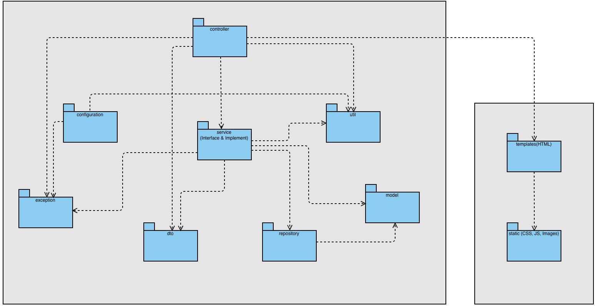
Figure 1.2.1:Package Diagram
Package Descriptions
No | Package | Description
01 | configuration | This is where all the original installation files that control the application's execution flow are located, often interfering with the Spring Boot process right from the start.
02 | controller | Acting as the "gateway" to the entire system, its main task is to receive HTTP requests from users (clients/browsers) and perform URL routing for processing.
03 | service | It contains all the "brainpower" (Business Logic) and business rules of the LMS project. Here, the system will calculate data and check conditions before deciding whether to save or query the database.
04 | repository | Responsible for direct communication with the database (MySQL/H2 database).
05 | model | It contains classes that represent the actual objects and concepts of the LMS's educational business logic. Specifically, these are JPA Entities.
06 | dto | This is where intermediate container objects are stored to carry data back and forth between the Controller layer and the Service/Interface layer.
07 | exception | Contains files/classes responsible for comprehensive error "catching" (catching errors).
08 | util | It contains general-purpose functions (Helper/Utils) that are used in many places within the application without being strictly tied to any specific business logic.
09 | resources/templates | This is where all the HTML interface files, along with the Thymeleaf tag technology, are stored. The files here are initially filled with empty data, and the Controller will load the actual content (student name, course name) before rendering and returning it to the client computer (Server-Side Rendering).
10 | resources/static | It contains all files that do not change the logic running on the user's machine (Client-Side), including CSS (interface styling, colors, fonts), JS Javascript (smooth click effects on the web), and the system's logo image library.

1.3 Database Design
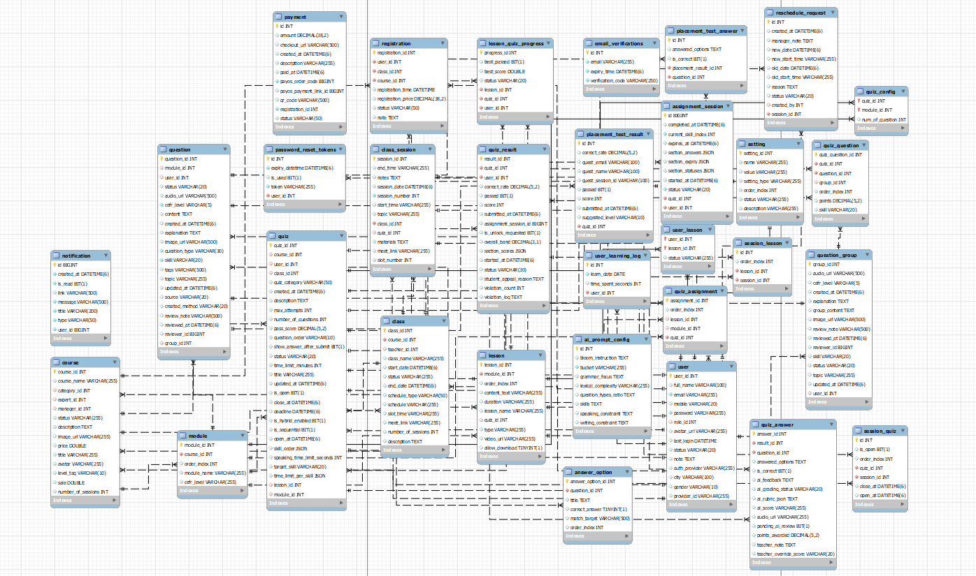
Table 1.3: SQL Database Design

1.3.1 Table setting
Description: EAV pattern table storing dynamic configurations and system categories (e.g., Roles, Categories) to minimize standalone tables.
Column Name | Data Type | Constraint/Key | Description
setting_id | INT | Primary Key, Auto Inc | Unique identifier for the configuration.
setting_type | VARCHAR(50) | NOT NULL | Category group ("COURSE_CATEGORY", "ROLE").
name | VARCHAR(255) | NOT NULL | Display name of the setting.
value | VARCHAR(255) | NOT NULL | Actual internal value.
description | TEXT |  | Detailed explanation.
order_index | INT | DEFAULT 0 | Sorting index for UI display.

1.3.2 Table user
Description: Centralized storage for all system user accounts including Admins, Managers, Experts, Teachers, and Students.
Column Name | Data Type | Constraint/Key | Description
user_id | INT | Primary Key, Auto Inc | Unique identifier for the user.
email | VARCHAR(255) | UNIQUE, NOT NULL | Account login identifier.
password | VARCHAR(255) | NOT NULL | Encrypted password (BCrypt). Nullable for SSO.
full_name | VARCHAR(100) |  | User's full name.
mobile | VARCHAR(20) | NOT NULL | Contact phone number.
avatar_url | VARCHAR(500) | Foreign Key | URL link to the profile picture.
city | VARCHAR(100) |  | City/Location of the user.
gender | VARCHAR(20) |  | User's gender.
role_id | INT | Foreign Key | References setting table for role permissions.
status | VARCHAR(20) | DEFAULT 'ACTIVE' | Account status ("Active", "Inactive", "Banned").
auth_provider | VARCHAR(50) |  | OAuth2 provider (e.g., "GOOGLE", "LOCAL").
provider_id | VARCHAR(255) |  | Third-party unique identifier.

1.3.3 Table course
Description: Defines the template and structural overview of a course syllabus.
Column Name | Data Type | Constraint/Key | Description
course_id | INT | Primary Key, Auto Inc | Course identifier.
course_name | VARCHAR(255) | NOT NULL | Full name of the course.
title | VARCHAR(255) |  | Short title/catchphrase.
description | TEXT |  | Detailed syllabus description.
category_id | INT | Foreign Key | Course category (References setting).
expert_id | INT | Foreign Key | Expert managing content.
manager_id | INT | Foreign Key | Manager handling general operations.
price | DECIMAL(10,2) | NOT NULL | Base price.
sale | DECIMAL(5,2) |  | Discount value/percentage.
level_tag | VARCHAR(50) |  | Certificate target tag (e.g., "B1", "IELTS 6.5").
image_url | VARCHAR(500) |  | Thumbnail image URL.
avatar | VARCHAR(500) |  | Secondary avatar image display.

1.3.4 Table class
Description:A specific operational class session opened based on a course curriculum template. Represents the actual delivery of a course to a cohort of students.
Column Name | Data Type | Constraint/Key | Description
class_id | INT | Primary Key, Auto Inc | Class identifier.
course_id | INT | Foreign Key | Parent course template blueprint.
teacher_id | INT | Foreign Key | Assigned primary teacher.
class_name | VARCHAR(255) | (Updated) NOT NULL | Internal class code (e.g., "IELTS-K01").
start_date | DATETIME(6) | (Updated) NOT NULL | Official opening date.
end_date | DATETIME(6) | (Updated) NOT NULL | Official closing date.
schedule_type | VARCHAR(50) |  | Type of schedule logic (e.g., "FIXED", "FLEXIBLE").
schedule | VARCHAR(255) |  | Days of the week (e.g., "Mon-Wed-Fri").
slot_time | VARCHAR(255) | (Updated) | Time frame (e.g., "18:00 - 20:00").
meet_link | VARCHAR(255) | (Updated) | Default Online meeting URL (Google Meet/Zoom).
number_of_sessions | INT | NOT NULL | Total expected class sessions to be delivered.
status | VARCHAR(255) | (Updated) DEFAULT 'PENDING' | Recruitment/Operation status ("OPEN", "CLOSED", "ONGOING").
description | TEXT | (New) | Specific notes or description for this particular class cohort.

1.3.5 Table registration
Description: Handles student enrollment transactions for purchasing courses or securing class seats.
Column Name | Data Type | Constraint/Key | Description
registration_id | INT | Primary Key, Auto Inc | Enrollment record ID.
user_id | INT | Foreign Key | Enrolled student.
class_id | INT | Foreign Key | Target class.
course_id | INT | Foreign Key | Selected course.
registration_time | DATETIME | NOT NULL | Timestamp of record creation.
registration_price | DECIMAL(10,2) | NOT NULL | Final finalized payable amount.
status | VARCHAR(20) | DEFAULT 'PENDING' | State of enrollment ("Approved", "Cancelled").
note | TEXT |  | Admin notes.

1.3.6 Table module
Description: Structural hierarchy mapping major chapters within a course.
Column Name | Data Type | Constraint/Key | Description
module_id | INT | Primary Key, Auto Inc | Module identifier.
course_id | INT | Foreign Key | Parent course.
module_name | VARCHAR(255) | NOT NULL | Title of the chapter.
order_index | INT | DEFAULT 0 | Sorting sequence.

1.3.7 Table lesson
Description: Granular study materials and lessons mapped under a specific module.
Column Name | Data Type | Constraint/Key | Description
lesson_id | INT | Primary Key, Auto Inc | Lesson identifier.
module_id | INT | Foreign Key | Parent module.
lesson_name | VARCHAR(255) | NOT NULL | Topic/Title of the lesson.
type | VARCHAR(50) | NOT NULL | Content format ("VIDEO", "DOC", "QUIZ", "READING").
video_url | VARCHAR(500) |  | Media URL iframe.
content_text | TEXT |  | Reading HTML content.
duration | INT |  | Expected studying duration (minutes).
quiz_id | INT | Foreign Key | In-video or embedded quiz identifier.

1.3.8 Table user_lesson
Description: Progress tracking mechanism logging the user's completion status per lesson.
Column Name | Data Type | Constraint/Key | Description
user_id | INT | Primary Key, Foreign Key | Student tracking identity.
lesson_id | INT | Primary Key, Foreign Key | Lesson being tracked.
status | VARCHAR(20) | NOT NULL | Progress tracking flag ("DONE", "IN_PROGRESS").

1.3.9 Table question_group
Description: A clustered container allowing multiple questions to map to a single passage, listening track, or media block (e.g., IELTS Reading Passage with 5 sub-questions).
Column Name | Data Type | Constraint/Key | Description
group_id | INT | Primary Key, Auto Inc | Cluster identifier.
title | VARCHAR(255) | (Deprecated) | Replaced by group_content/topic.
content | TEXT | (Deprecated) | Replaced by group_content.
audio_url | VARCHAR(500) | (New) | Shared listening track for the group.
cefr_level | VARCHAR(5) | (New) | Difficulty level of the reading/listening passage.
created_at | DATETIME(6) | (New) | Timestamp of creation.
explanation | TEXT | (New) | General explanation for the entire passage/group.
group_content | TEXT | (New) | Shared reading passage or common stimulus text.
image_url | VARCHAR(500) | (New) | Shared visual stimulus (e.g., Task 1 Chart).
review_note | VARCHAR(500) | (New) | Feedback from experts during the QA/Review phase.
reviewed_at | DATETIME(6) | (New) | Timestamp when the group was approved/rejected.
reviewer_id | BIGINT | (New) Foreign Key | Expert who reviewed this item.
skill | VARCHAR(20) | (New) | Primary skill assessed (e.g., "READING", "LISTENING").
status | VARCHAR(20) | (New) | Lifecycle status ("DRAFT", "APPROVED", "REJECTED").
topic | VARCHAR(255) | (New) | Subject matter topic tag.
updated_at | DATETIME(6) | (New) | Timestamp of last modification.
user_id | INT | (New) Foreign Key | Author/Creator of the group.

1.3.10 Table question
Description: Centralized Master Item Bank library holding standalone operational questions formatted by CEFR specs. Fuel for AI dynamic generation and fixed quiz mapping.
Column Name | Data Type | Constraint/Key | Description
question_id | INT | Primary Key, Auto Inc | Question identity.
module_id | INT | Foreign Key | Contextual module scope.
user_id | INT | Foreign Key | Teacher/author origin.
cefr_level | VARCHAR(5) | (Updated) | Difficulty tagging (e.g., "A1", "B2").
skill | VARCHAR(20) | (Updated) | Competency tag ("LISTENING", "READING", "WRITING").
topic | VARCHAR(255) | (Updated) | Knowledge theme tag.
question_type | VARCHAR(50) | NOT NULL | Query format ("MULTIPLE_CHOICE", "FILL_IN_BLANK", "ESSAY").
content | TEXT | NOT NULL | The query string prompt or essay topic.
audio_url | VARCHAR(500) |  | Sourced audio media for this specific question.
image_url | VARCHAR(500) |  | Sourced picture media.
explanation | TEXT |  | Post-grading educational rationale for students.
status | VARCHAR(20) | (New) | Approval status in the item bank ("PENDING", "APPROVED").
created_at | DATETIME(6) | (New) | Timestamp of creation.
updated_at | DATETIME(6) | (New) | Timestamp of last update.
tags | VARCHAR(500) | (New) | Comma-separated searchable tags.
source | VARCHAR(20) | (New) | Origin of question (e.g., "MANUAL", "AI_GENERATED").
created_method | VARCHAR(20) | (New) | Method used to input the question into the system.
review_note | VARCHAR(500) | (New) | Feedback from Expert reviewer.
reviewed_at | DATETIME(6) | (New) | Timestamp of review completion.
reviewer_id | BIGINT | (New) Foreign Key | ID of the Expert who conducted the review.

1.3.11 Table answer_option
Description: Discrete answer options tightly coupled to a specific question supporting autograding.
Column Name | Data Type | Constraint/Key | Description
answer_option_id | INT | Primary Key, Auto Inc | Option identifier.
question_id | INT | Foreign Key | Parent question (ON DELETE CASCADE).
title | TEXT | NOT NULL | Literal text of the answer.
correct_answer | BOOLEAN | DEFAULT 0 | Autograding flag for correct choice.
match_target | TEXT |  | Companion pairs used explicitly in Matching type questions.
order_index | INT | DEFAULT 0 | Rendering order.

1.3.12 Table quiz
Description: Definition form of an exam/test acting standalone or bounded to a curriculum. Contains comprehensive constraints for test delivery, including anti-cheat and skill-based pacing.
Column Name | Data Type | Constraint/Key | Description
quiz_id | INT | Primary Key, Auto Inc | Exam blueprint identifier.
title | VARCHAR(255) | NOT NULL | Exam display name.
description | TEXT |  | Scope explanation and instructions.
quiz_category | VARCHAR(50) | NOT NULL | Contextual usage ("ENTRY_TEST", "MOCK_TEST", "QUIZ").
time_limit_minutes | INT | NOT NULL | Strict countdown timer for the entire exam.
pass_score | DECIMAL(5,2) | NOT NULL | Passing threshold.
max_attempts | INT | DEFAULT 1 | Retake allowance limit.
question_order | VARCHAR(10) | (Updated) DEFAULT 'FIXED' | Rendering mode ("RANDOM", "FIXED").
show_answer_after_submit | BIT(1) | (Updated) DEFAULT 1 | Flag dictating if post-exam review is permitted.
course_id | INT | (New) Foreign Key | Binds quiz globally to a course.
class_id | INT | (New) Foreign Key | Binds quiz locally to a specific class.
user_id | INT | (New) Foreign Key | Teacher who created the quiz.
module_id | INT | (New) Foreign Key | Binds quiz to a curriculum module.
lesson_id | INT | (New) Foreign Key | Binds quiz as an interactive lesson activity.
created_at | DATETIME(6) | (New) | Creation timestamp.
updated_at | DATETIME(6) | (New) | Modification timestamp.
status | VARCHAR(20) | (New) | Lifecycle status ("DRAFT", "PUBLISHED").
number_of_questions | INT | (New) | Total configured questions.
is_open | BIT(1) | (New) | Global toggle allowing/blocking entry.
open_at | DATETIME(6) | (New) | Scheduled open time.
close_at | DATETIME(6) | (New) | Scheduled hard-close time.
deadline | DATETIME(6) | (New) | Submission deadline for assignments.
is_hybrid_enabled | BIT(1) | (New) | Supports mixed AI grading and Teacher grading.
is_sequential | BIT(1) | (New) | Forces students to answer in strict order without going back.
skill_order | JSON | (New) | Defines the sequence of skills (e.g., Listening -> Reading).
target_skill | VARCHAR(20) | (New) | Specific skill focused by this quiz.
time_limit_per_skill | JSON | (New) | Pacing constraints (e.g., Reading: 60 mins, Writing: 60 mins).
speaking_time_limit_seconds | INT | (New) | Specific timer for speaking recording sessions.

1.3.13 Table quiz_config
Description: Blueprint logic generator for dynamically drawing random questions per specific modules.
Column Name | Data Type | Constraint/Key | Description
quiz_id | INT | Primary Key, Foreign Key | Triggers test blueprint.
module_id | INT | Primary Key, Foreign Key | Triggers library scope.
num_of_question | INT |  | Amount of random queries demanded from the module.

1.3.14 Table quiz_question
Description: Mapped definition assigning exact predetermined fixed questions into an exam paper.
Column Name | Data Type | Constraint/Key | Description
quiz_question_id | INT | Primary Key, Auto Inc | Mapping record.
quiz_id | INT | Foreign Key | Owning test.
question_id | INT | Foreign Key | Bound fixed query.
group_id | INT | Foreign Key | Bound cluster group (if applied).
points | DECIMAL(5,2) | DEFAULT 1.0 | Evaluation weighting for this specific occurrence.

1.3.15 Table quiz_result
Description: Final submission scorecard archiving performance history for authenticated users. Acts as the primary table for analytics, grading flows, and cheating detection.
Column Name | Data Type | Constraint/Key | Description
result_id | INT | Primary Key, Auto Inc | Audit submission identifier.
quiz_id | INT | Foreign Key | Executed exam.
user_id | INT | Foreign Key | Student identity.
score | INT | (Updated) NOT NULL | Raw points successfully achieved.
correct_rate | DECIMAL(5,2) | NOT NULL | Percentage formulation of accuracy.
passed | BIT(1) | (Updated) NOT NULL | Final evaluation (1: Pass / 0: Fail).
submitted_at | DATETIME(6) | (Updated) NOT NULL | Timestamp of closure/submission.
assignment_session_id | BIGINT | (New) Foreign Key | Maps to the temporal test-taking session context.
started_at | DATETIME(6) | (New) | Timestamp when student clicked "Start".
status | VARCHAR(30) | (New) | Grading status ("PENDING_GRADING", "COMPLETED").
section_scores | JSON | (New) | Breakdown of scores per skill (Reading: 6.5, Listening: 7.0).
overall_band | DECIMAL(3,1) | (New) | Calculated IELTS/CEFR equivalent band score.
is_unlock_requested | BIT(1) | (New) | Flag if student requested to reopen a locked/timed-out test.
student_appeal_reason | TEXT | (New) | Text input if student disputes the AI/Teacher grade.
violation_count | INT | (New) | Anti-cheat: Number of times user switched tabs/lost focus.
violation_log | TEXT | (New) | Anti-cheat: Detailed JSON/text logs of suspicious activities.

1.3.16 Table quiz_answer
Description: Deep telemetry log retaining students' exact micro-interactions. Crucial for AI integrated grading (LLM prompts evaluate subjective text) and Teacher overrides.
Column Name | Data Type | Constraint/Key | Description
answer_id | INT | Primary Key, Auto Inc | Action logger identity.
result_id | INT | Foreign Key | Parent scorecard.
question_id | INT | Foreign Key | Handled query.
answered_options | TEXT |  | JSON String mapping exact student interactions/choices/essay text.
is_correct | BIT(1) | (Updated) | Localized autograding validation flag.
ai_feedback | TEXT | (New) | Feedback generated by LLM (e.g., Grammar correction, lexical resource).
ai_grading_status | VARCHAR(20) | (New) | Integration state ("PENDING_AI", "AI_GRADED", "FAILED").
ai_rubric_json | TEXT | (New) | Detailed breakdown of AI scoring based on IELTS/CEFR rubrics.
ai_score | VARCHAR(255) | (New) | Raw band/score returned strictly by the LLM.
audio_url | VARCHAR(255) | (New) | Media link if student submitted a Speaking recording.
pending_ai_review | BIT(1) | (New) | Flag indicating this answer needs LLM processing via Queue.
points_awarded | DECIMAL(5,2) | (New) | Actual points granted (AI + Teacher adjustment).
teacher_note | TEXT | (New) | Feedback directly from human Teacher.
teacher_override_score | VARCHAR(20) | (New) | Score manually adjusted by Teacher overriding AI.

1.3.17 Table password_reset_token
Description: Manages the workflow for the "Forgot Password" feature preventing token reuse.
Column Name | Data Type | Constraint/Key | Description
id | BIGINT | Primary Key, Auto Inc | Primary key identifier.
user_id | INT | Foreign Key | The user requesting reset.
token | VARCHAR(255) | UNIQUE, NOT NULL | Generated UUID token.
expiry_datetime | DATETIME | NOT NULL | Expiration timestamp.
is_used | BOOLEAN | DEFAULT 0 | Flag indicating token reuse status (0: Unused).

1.3.18 Table email_verifications
Description: Stores verification codes sent via email for new user registrations or account verification.
Column Name | Data Type | Constraint/Key | Description
id | BIGINT | Primary Key, Auto Inc | Unique identifier for the verification record.
email | VARCHAR(255) | NOT NULL | The email address receiving the verification code.
verification_code | VARCHAR(100) | NOT NULL | The OTP or hash code used for confirmation.
expiry_time | DATETIME | NOT NULL | The exact timestamp when the verification code expires.

1.3.19 Table class_session
Description: Manages individual daily sessions within a class. Used for attendance tracking, daily assignments, and calendar rendering.
Column Name | Data Type | Constraint/Key | Description
session_id | INT | Primary Key, Auto Inc | Session identifier.
class_id | INT | Foreign Key | Parent class.
session_number | INT | NOT NULL | Chronological sequence (1, 2, 3...).
session_date | DATETIME(6) | (Updated) NOT NULL | Specific date of the lecture.
start_time | VARCHAR(255) | (Updated) | Exact start time (string format or HH:MM).
end_time | VARCHAR(255) | (Updated) | Exact end time.
topic | VARCHAR(255) |  | Actual topic covered (overriding the master syllabus if needed).
quiz_id | INT | Foreign Key | Direct quiz/assignment mapped natively as primary homework.
materials | TEXT |  | Links to daily slide/material files.
notes | TEXT |  | Internal Teacher notes.
meet_link | VARCHAR(255) | (New) | Specific Zoom/Meet link for this single day.
slot_number | INT | (New) | Maps to a specific institutional time slot (e.g., Slot 1 = 7AM).

1.3.20 Table payment
Description: Tracks financial transactions securely via third-party gateways (e.g., VNPay, PayOS).
Column Name | Data Type | Constraint/Key | Description
id | INT | Primary Key, Auto Inc | Transaction identifier.
registration_id | INT | Foreign Key | Binds payment to the enrollment.
amount | DECIMAL(10,2) | NOT NULL | Exact transacted money.
payos_order_code | VARCHAR(100) |  | Vendor gateway order code tracking.
payos_payment_link_id | VARCHAR(255) |  | Webhook callback verification ID.
checkout_url | VARCHAR(500) |  | Vendor routing URL.
qr_code | TEXT |  | Raw QR String code representation.
created_at | DATETIME | NOT NULL | Initialization timestamp.
paid_at | DATETIME |  | Fulfillment timestamp.
status | VARCHAR(20) | DEFAULT 'PENDING' | Payment state ("PAID", "PENDING", "CANCELLED").

1.3.21 Table session_quiz
Description: Many-to-Many mapping table attaching multiple quizzes/assignments to a single class session.
Column Name | Data Type | Constraint/Key | Description
id | INT | Primary Key, Auto Inc | Mapping record identity.
session_id | INT | Foreign Key | Targeted class session.
quiz_id | INT | Foreign Key | The quiz mapped as homework/test.
order_index | INT | DEFAULT 0 | Display sequence.
is_open | BOOLEAN | DEFAULT 1 | Flag dictating if the quiz is currently accepting submissions.

1.3.22 Table placement_test_answer
Description: Action tracking logging the guest user's interaction similarly parallel to quiz_answer.
Column Name | Data Type | Constraint/Key | Description
id | BIGINT | Primary Key, Auto Inc | Answer trace identifier.
placement_result_id | INT | Foreign Key | Bound to the guest scorecard.
question_id | INT | Foreign Key | Processed query.
answered_options | TEXT |  | Picked selection string.
is_correct | BOOLEAN |  | Checkpoint local validation test.

1.3.23 Table placement_test_result
Description: Specialized temporary scorecard tailored for anonymous or guest visitors taking entry placement exams.
Column Name | Data Type | Constraint/Key | Description
id | INT | Primary Key, Auto Inc | Guest scorecard identity.
quiz_id | INT | Foreign Key | Handled exam.
guest_name | VARCHAR(100) | NOT NULL | Provided a temporary name.
guest_email | VARCHAR(255) | NOT NULL | Provided temporary email.
guest_session_id | VARCHAR(255) | NOT NULL | Browser/Cookie UUID bridging session context.
score | DECIMAL(5,2) | NOT NULL | Evaluated points.
correct_rate | DECIMAL(5,2) | NOT NULL | Captured accuracy rate.
passed | BOOLEAN |  | Binary evaluation status.
suggested_level | VARCHAR(100) |  | Output diagnostic recommendation (e.g., "IELTS 5.0 - CEFR B1").

1.3.24 Table notification

Description: System-wide alert and notification delivery system. Pushes alerts for graded tests, upcoming deadlines, or schedule changes.
Column Name | Data Type | Constraint/Key | Description
id | BIGINT | Primary Key, Auto Inc | Notification identifier.
user_id | BIGINT | Foreign Key | Recipient user.
title | VARCHAR(200) | NOT NULL | Notification headline.
message | VARCHAR(500) | NOT NULL | Full notification body text.
type | VARCHAR(20) |  | Category ("SYSTEM", "GRADING", "DEADLINE").
link | VARCHAR(500) |  | Hyperlink redirect when notification is clicked.
is_read | BIT(1) | DEFAULT 0 | Read/Unread flag.
created_at | DATETIME(6) | NOT NULL | Timestamp generated.

1.3.25 Table reschedule_request
Description: Operations workflow table allowing Teachers to formally request a class date/time change and wait for Manager approval.
Column Name | Data Type | Constraint/Key | Description
id | INT | Primary Key, Auto Inc | Request identifier.
session_id | INT | Foreign Key | The specific class session being rescheduled.
created_by | INT | Foreign Key | The user (Teacher) initiating the request.
old_date | DATETIME(6) | NOT NULL | Original scheduled date.
old_start_time | VARCHAR(255) | NOT NULL | Original start time.
new_date | DATETIME(6) | NOT NULL | Requested new date.
new_start_time | VARCHAR(255) | NOT NULL | Requested new start time.
reason | TEXT | NOT NULL | Justification for schedule change.
manager_note | TEXT |  | Note/Feedback from approving manager.
status | VARCHAR(20) | DEFAULT 'PENDING' | Workflow state ("PENDING", "APPROVED", "REJECTED").
created_at | DATETIME(6) | NOT NULL | Timestamp of request.

1.3.26 Table lesson_quiz_progress
Description: Continuous tracking of a student's attempt across lesson-embedded quizzes, logging best scores for gamification/passing criteria.
Column Name | Data Type | Constraint/Key | Description
progress_id | INT | Primary Key, Auto Inc | Progress record identity.
user_id | INT | Foreign Key | Tracking student.
lesson_id | INT | Foreign Key | Target lesson.
quiz_id | INT | Foreign Key | Embedded quiz.
best_score | DOUBLE |  | Highest score achieved across multiple attempts.
best_passed | BIT(1) |  | Flag indicating if they ever passed.
status | VARCHAR(20) |  | Status ("INCOMPLETE", "COMPLETED").

1.3.27 Table assignment_session
Description: Crucial table for skill-based adaptive testing. Manages the active state of an exam, remembering which skill the user is currently on, and handling rigid timeouts to prevent cheating.
Column Name | Data Type | Constraint/Key | Description
id | BIGINT | Primary Key, Auto Inc | Session context identifier.
quiz_id | INT | Foreign Key | Handled exam.
user_id | INT | Foreign Key | Test taker.
started_at | DATETIME(6) | NOT NULL | Official clock start.
expires_at | DATETIME(6) |  | Official hard-cutoff time.
completed_at | DATETIME(6) |  | Timestamp when final section was submitted.
current_skill_index | INT | DEFAULT 0 | Tracks progression (e.g., 0 = Listening, 1 = Reading).
section_answers | JSON |  | Temporary cache of answers in case of browser crash.
section_expiry | JSON |  | Precise timeouts for individual skills.
section_statuses | JSON |  | Tracks state of each skill section.
status | VARCHAR(20) |  | Session lifecycle ("ACTIVE", "EXPIRED", "FINISHED").

1.3.28 Table user_learning_log
Description: Analytics data warehouse capturing the raw time a user spends interacting with the platform per day.
Column Name | Data Type | Constraint/Key | Description
id | INT | Primary Key, Auto Inc | Log identifier.
user_id | INT | Foreign Key | Target student.
learn_date | DATE | NOT NULL | Specific calendar date of interaction.
time_spent_seconds | INT | DEFAULT 0 | Aggregated seconds spent watching video/reading.

1.3.29 Table quiz_assignment
Description: Structural mapping allowing a single quiz blueprint to be assigned as a formal task within a course module or lesson.
Column Name | Data Type | Constraint/Key | Description
assignment_id | INT | Primary Key, Auto Inc | Mapping identifier.
quiz_id | INT | Foreign Key | Target quiz blueprint.
module_id | INT | Foreign Key | Target module (if assigned at module level).
lesson_id | INT | Foreign Key | Target lesson (if assigned at lesson level).
order_index | INT | DEFAULT 0 | Display sequence in curriculum tree.

1.3.30 Table ai_prompt_config
Description: The core configuration engine for the LLM Integration. Stores highly specific prompts, grading rubrics, and constraints that dictate how the AI should behave when generating questions or grading essays.
Column Name | Data Type | Constraint/Key | Description
id | INT | Primary Key, Auto Inc | Configuration identifier.
bucket | VARCHAR(255) |  | Scope category (e.g., "IELTS_WRITING_TASK_1", "CEFR_A2_READING").
bloom_instruction | TEXT |  | System instructions strictly dictating Bloom's Taxonomy cognitive level.
grammar_focus | TEXT |  | Rules dictating specific grammar structures the AI must test.
lexical_complexity | VARCHAR(255) |  | Vocabulary boundary constraint (e.g., "Do not use C1 vocab for A2 test").
skills | TEXT |  | Target skills focused by the prompt.
question_types_ratio | TEXT |  | JSON/String defining mix ratio (e.g., "80% MCQ, 20% Matching").
speaking_constraint | TEXT |  | Rubric details strictly for AI evaluating audio transcriptions.
writing_constraint | TEXT |  | Rubric details strictly for AI evaluating essay coherence/cohesion.

1.3.31 Table session_lesson
Description: Many-to-Many mapping to link specific lesson materials to a scheduled daily class session.
Column Name | Data Type | Constraint/Key | Description
id | INT | Primary Key, Auto Inc | Mapping record identity.
session_id | INT | Foreign Key | Target class session.
lesson_id | INT | Foreign Key | Targeted curriculum lesson.
order_index | INT | DEFAULT 0 | Display sequence.

2. Detailed Design

2.1 Authentication

2.1.1 Class Diagram Authentication

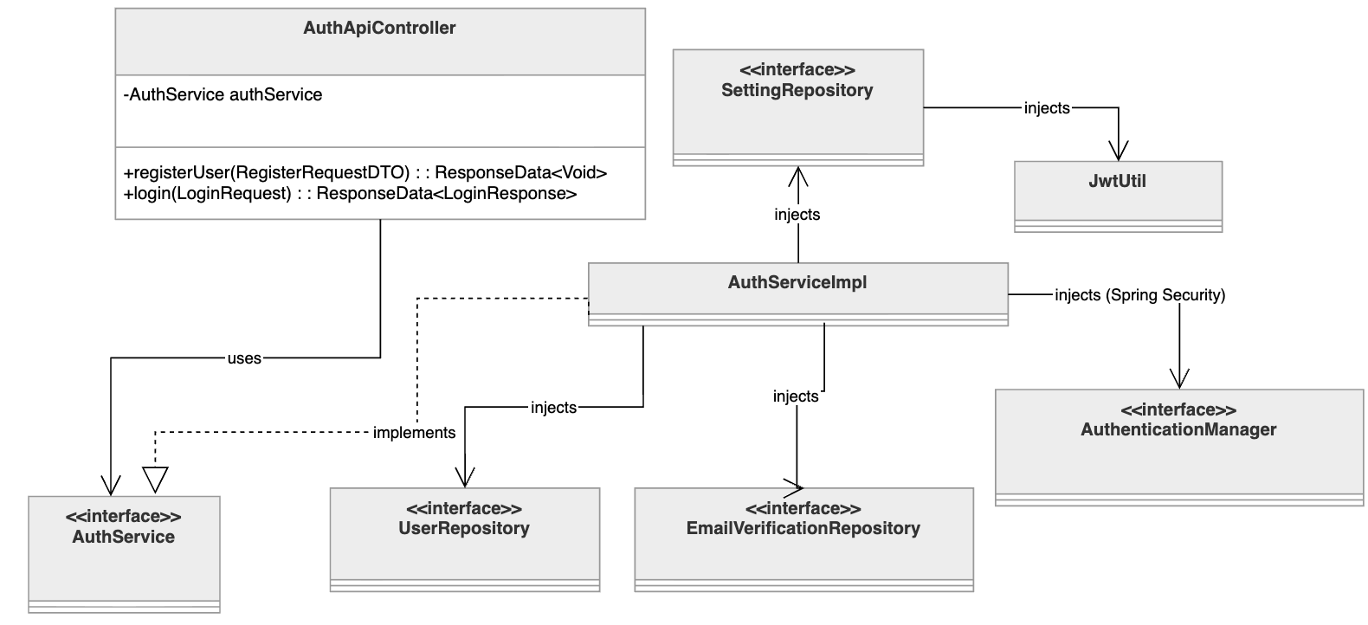
Table 2.1.1: Class Diagram Authentication

2.1.2 Sequence Diagram Authentication
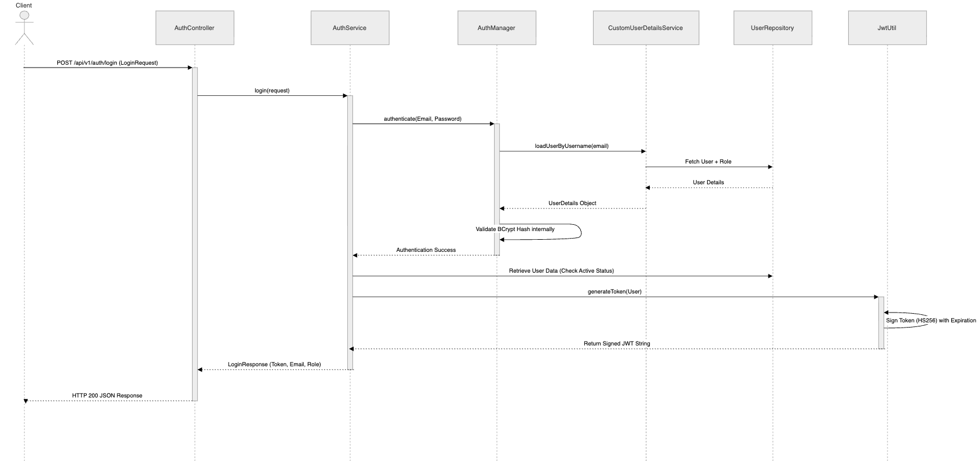 Table 2.1.2: Sequence Diagram Authentication

2.2 Course

2.2.1 Class Diagram Course
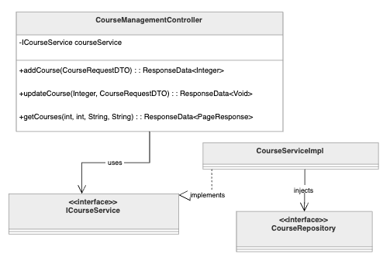
Table 2.2.1: Class Diagram Course

2.2.2 Sequence Diagram Course

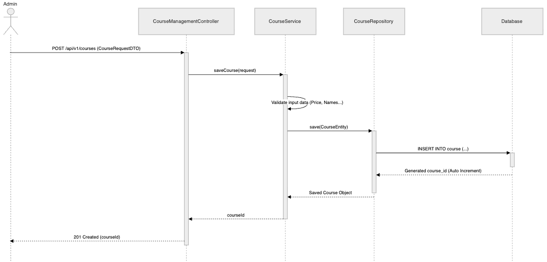
Table 2.2.2: Sequence Diagram Course

2.3 Student

2.3.1 Class Diagram Students register for the course
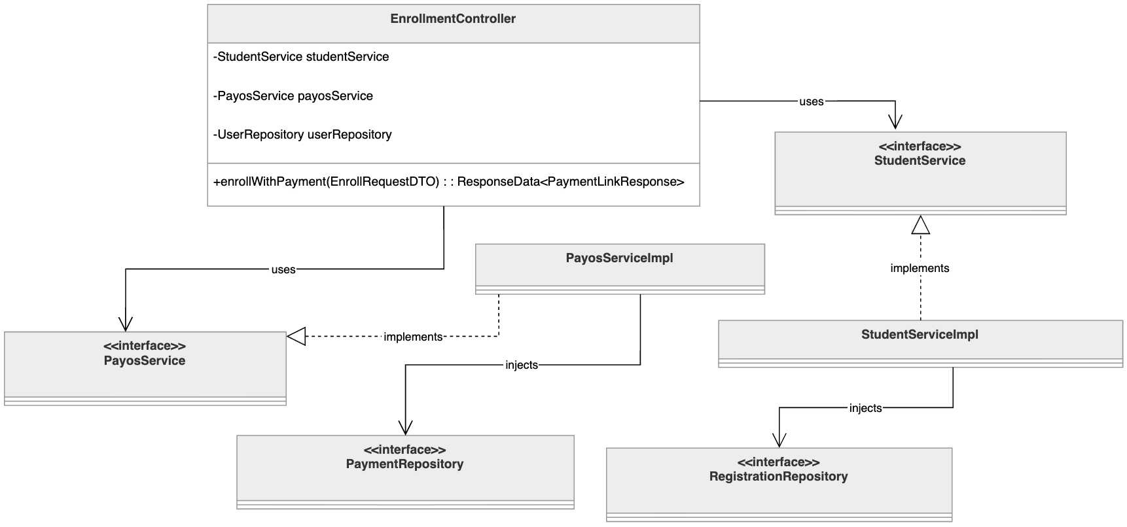
Table 2.3.1: Class Diagram Students register for the course

2.3.2 Sequence Diagram Students register for the course
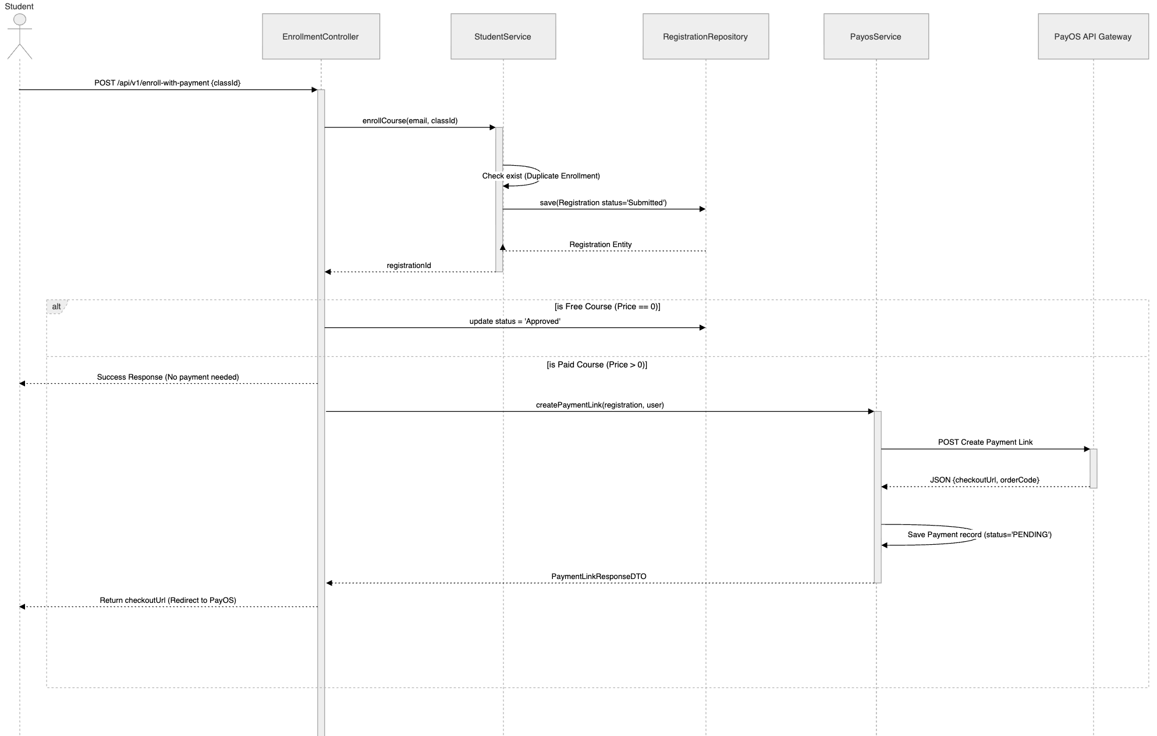
Table 2.3.2: Sequence Diagram Students register for the course

2.4 Quiz

2.4.1 Class Diagram Class
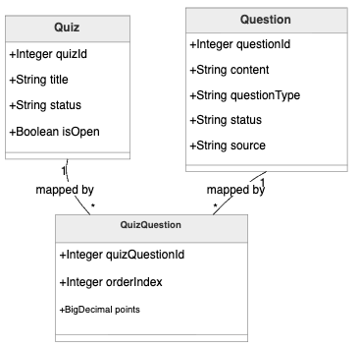
Table 2.4.1: Class Diagram Quiz

2.4.2 Sequence Diagram Quiz
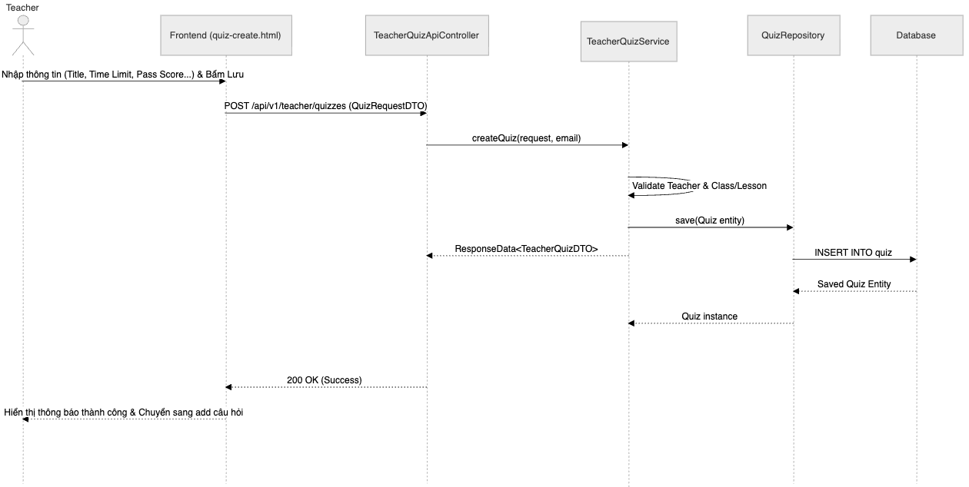
Table 2.4.2: Sequence Diagram Quiz

2.5 AI

2.5.1 Class Diagram Generate Question

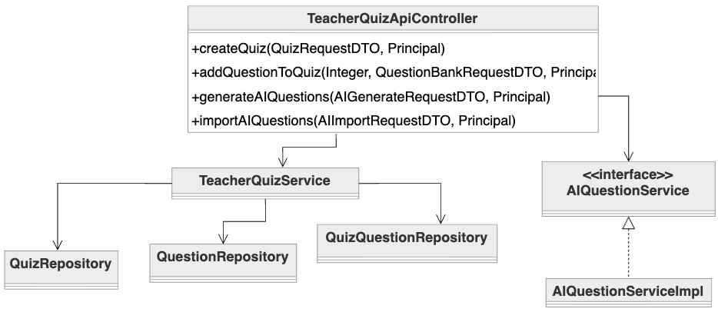
Table 2.5.2: Sequence Diagram Generate Question

2.5.2 Sequence Diagram Generate Question

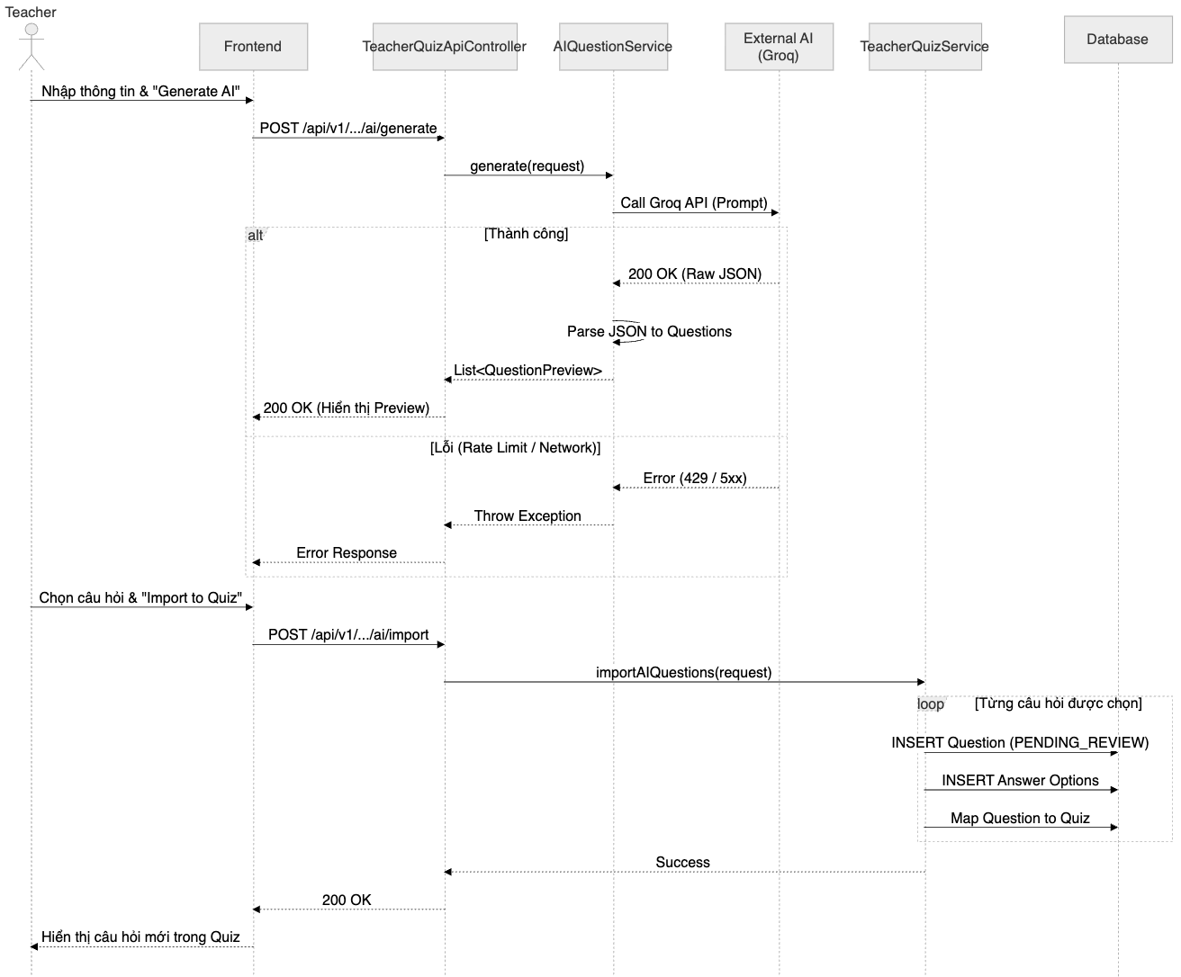
Table 2.5.2: Sequence Diagram Generate Question

2.6 Granding

2.5.2 Class Diagram Granding 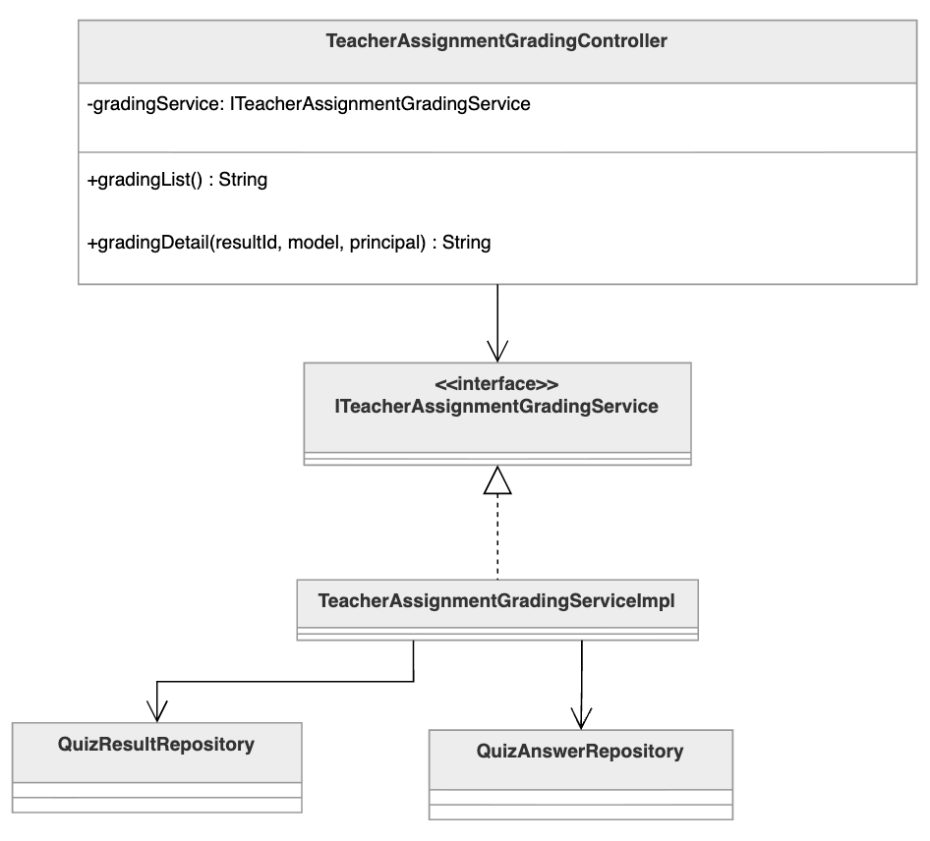
Table 2.6.2: Sequence Diagram Granding

2.5.2 Sequence Diagram Granding 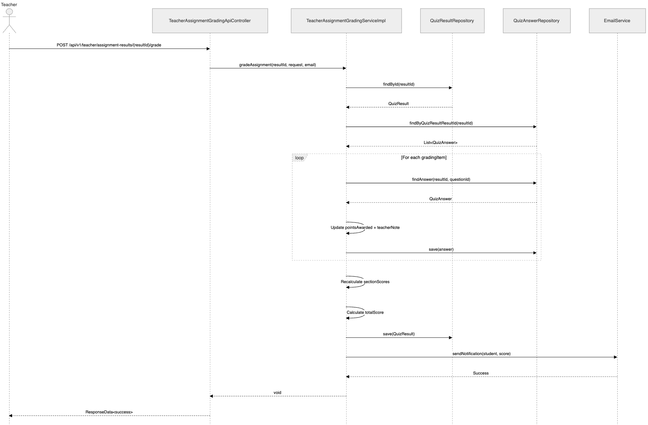
Table 2.6.2: Sequence Diagram Granding

